# Instructions - Exercise 2.4 – Routing in Action

**Layout(s)**

Composer List

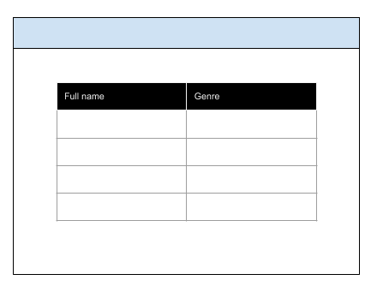

About

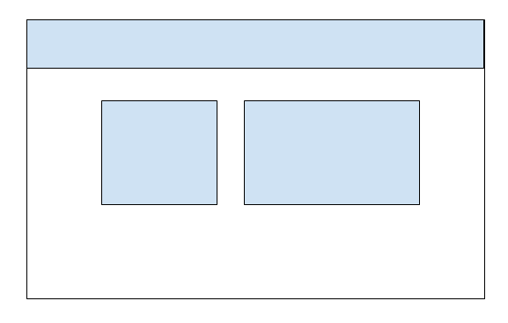

Contact

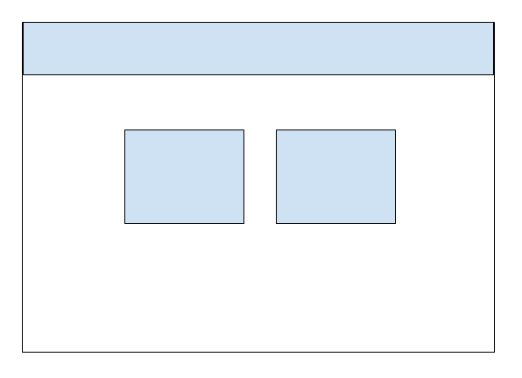

The final solution can be located at: <https://buwebdev.github.io/composer-app/>

composer-app, part 1

**Instructions**

* ~~Generate a new Angular application and name it composer-app~~
  + ~~Enter “y” for routing~~
* ~~Install and wire bootstrap and jquery~~
* ~~Generate three new components: composer-list, contact, about~~
* ~~Remove the boilerplate code from the app.component.html file and add the <router-outlet> directive~~
* ~~Create a new bootstrap layout with a top navigation and a main body container~~
* ~~Top navigation links: Composer List, About, Contact Us~~
* ~~Link each component: composer-list, about, contact to the top navigation links (hint: use the app-routing.module.ts file)~~
* ~~Research composers and select one composer to write a 75-word bio.  Add this to the about.component.html page.  You will also need to include a bio image of the composer, which will be placed to the left of the 75-word write-up.  Make sure the image is royalty free and include the source as a caption.~~
* Update the HTML in the contact.component.html to tell users how they may contact the selected composer
  + At minimum there should be two side-by-side divs.  ~~The left <div> should contain a header and a street address.  The right <div> should contain a header and a phone number.  For the headers, use Bootstrap icons that best represent each section~~
* ~~composer-list.component.ts~~
  + ~~Create a Composer class with two fields:~~
    - ~~fullName~~
    - ~~genre~~
  + ~~In constructor accept two parameters: fullName and genre and map them to the class fields~~
  + ~~In the component, add a variable called composers and give it a data type of an Array<Composer>~~
  + ~~In the components constructor, create a new Array and initialize it with 5 new Composer objects~~
* ~~composer-list-component.html~~
  + ~~Using the *ngFor directive, loop over the array of composers and output the results to a Bootstrap table~~
  + ~~The Bootstrap table should have two column headers: “Full name” and “Genre”~~
* ~~Run and test the application~~